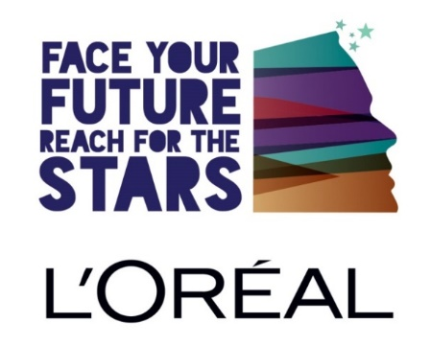
“Everything I learnt was great; I learnt that attitude is everything. This was the best trip I have ever had in my life. Now I know anything is possible for me.”
-Rebecca

What’s your plan once you’ve left school?
Already left school and wondering what’s next?
Now’s Your Chance to FACE YOUR FUTURE!

If you are in care and are between 16-18 years, in your final year of school, or have already left school, you are invited to be a part of FACE YOUR FUTURE 2021.

Hosted by L’Oréal New Zealand and in partnership with Caring Families Aotearoa, Face Your Future will focus on positive and inspiring stories from people whom have pushed through some tough times in their lives to go on and be super successful in their personal lives, businesses and careers. This event explores exciting Career Pathways, Interview Skills, Confidence & Communication tips as well as a session on Personal Presentation.

Each participant will receive generous L’Oréal gifts and will have the chance to win some fantastic prizes! But more importantly, it is our hope that each young person leaves with a sense of inspiration and confidence that it is possible to “Reach for the Stars” to achieve their hopes and dreams.

This two-day event is open to rangatahi (young people) in the care of caregivers or agencies who are members of Caring Families Aotearoa. Young people whom have NOT attended this event previously are eligible to register. Numbers are limited to the first 50 young people who register.

Unfortunately, due to space restrictions, we are unable to accommodate Caregivers or Social Workers at this event.

DAY 1: Wednesday 21 April 2021, L’Oréal Academy, Auckland City, 9:30am-4:00pm
- Inspirational speakers share their personal stories and road to success.
- Shared ideas on jobs and careers to help build an exciting future and gain new tools to help you get there.
- GIRLS: Get all the tips and tricks from NZ’s top stylists and makeup artists.
- GUYS: Meet some special guests in the “Man Cave,” and get a cool haircut.

DAY 2: Thursday 22 April 2021, L’Oréal Academy, Auckland City for the morning and then L’Oréal Distribution Centre, Pukekohe
9:30am-3:30pm
- Find out how the largest beauty company in the world operates and meet the staff that helps make it a success.
- Learn how to be ready for the workplace.
- Meet and talk to a panel of potential employee.
- Visit the L’Oréal Distribution Centre to see how it works and meet the team.
- Receive your own complimentary and personalised L’Oréal products.

Lunch is provided on both days and it is FREE to attend!

Registrations Close on Friday 12 February 2021
(Caregiver/Agency Social Worker to register the young person.)

Name of YOUNG PERSON:
Preferred Name:
Date of Birth: |  |  |  |  | Gender:  (tick one) | Male:  Female:
Address:
Address:
City: |  |  |  |  | Post Code:
Landline: |  |  |  |  | Cellphone:
Email:
Currently Attending School ☐ / as Left School ☐ (tick one)
Name of Caregiver/Social Worker:
Agency:
Address:
Address:
City: |  |  |  | Post Code:
Landline: |  |  |  | Cellphone:
Email:

EMERGENCY CONTACT DETAILS (please provide at least 2 sets of contact details)

Contact 1: Emergency Contact
Name: |  | Relationship:
Address:
Day Phone: |  | Evening Phone:
Mobile:
Contact 2: Alternative contact
Name: |  | Relationship:
Address:
Day Phone: |  | Evening Phone:
Mobile:
CONSENT TO ATTEND
I agree to taking part in the L’Oréal Face your Future and have received sufficient information on which to base a decision. I agree to their participation in the activities described. I acknowledge the need for them to behave responsibly.
I understand that the Caring Families Aotearoa and L’Oréal NZ do not accept responsibility for loss or damage to personal property and that it is my responsibility to check my own insurance policy.
Name:
Signature: |  |  |  | Date:

CONSENT TO PHOTOGRAPH/VIDEO - To be read and signed by young person and their guardian/s.
I agree to be Photographed/Videoed by L’Oréal NZ which may be reproduced for non-commercial use to promote L’Oréal Face Your Future in conjunction with Caring Families Aotearoa.

Agree (tick box): | ☐ |  | Do not Agree (tick box): | ☐
Signature  (Young Person): |  |  |  |  | Date:
Signature (Guardian): |  |  |  |  | Date:

HEALTH PROFILE
1. Please tick if your child has any of the following:
Migraine | ☐ | Epilepsy |  |  |  | ☐ |  | Asthma |  |  |  | ☐
Diabetes | ☐ | Travel sickness |  |  |  | ☐ |  | Fits of any type |  |  |  | ☐
Chronic nose bleeds | ☐ | Heart condition |  |  |  | ☐ |  | Dizzy spells |  |  |  | ☐
Colour blindness | ☐ | Other (Please specify)
ADHD | ☐
2. Is your child currently taking medication? |  |  |  | Yes |  | ☐ |  |  |  | No |  |  |  | ☐
(only applicable if rangatahi is travelling from outside of Auckland)
If YES, please state: Health condition/s:
Name of medication/s:
Dosage and time/s to be taken:
Other Treatment:

3. Is your child allergic to any of the following?
 | Yes |  |  |  | No |  |  |  |  | Please specify
Prescription medication |  |  | ☐ |  |  | ☐
Food |  |  | ☐ |  |  | ☐
Insect bites/stings
Other allergies
What treatment is required?
4. Outline any dietary requirements:

5. Is there any information the staff should know to ensure the physical and emotional safety of your child? (For example cultural practices; disability; anxiety; about heights/darkness/small spaces; pregnancy; behaviour or emotional problems).
Yes | ☐ | No | ☐
If YES, please state or attach the information.

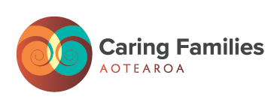
Please provide the contact details (as outlined above) of the young person/people who wishes to attend to:

Jennifer Kinsella
Caring Families Aotearoa
National Office
Free Call: 0800 693 323 l Text: TXT: 027 501 0330,
Email: events@caringfamilies.org.nz or
Post: PO Box 30-188, Lower Hutt 5040

